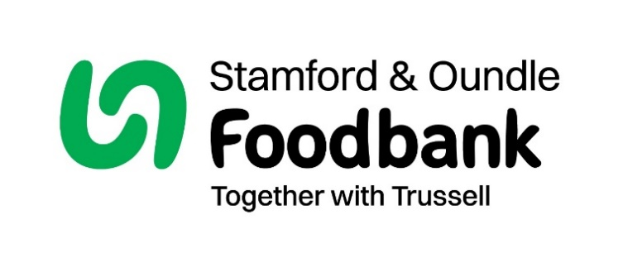

**Stamford and Oundle Foodbank**

**Trustee – Volunteer position a General Trustee with Oundle Focus**

**About Stamford and Oundle Foodbank**

Stamford and Oundle Foodbank is focused on the prevention or relief of poverty in Stamford and Oundle and surrounding area in particular, but not exclusively, by providing emergency food supplies to individuals in need, and doing so guided by the principles and values of Christian faith.

Stamford and Oundle Foodbank believes that no one in the community should face either going hungry or food poverty, and will therefore provide three days’ worth of nutritionally balanced emergency food as well as support to local people who are referred to us in crisis.

Last year 2,361 emergency food parcels were provided; 754 of these were to children. Subsequently, we have seen a trend of increasing need in the past year. In addition to providing food, basic toiletries, and additional support in the winter (such as blankets and hot water bottles), we also offer further assistance by signposting to other community services as well as liaising with supporting referrers. Stamford and Oundle Foodbank has been successful in obtaining a grant from the Trussell Trust to commission Citizen’s Advice staff in both centres to provide wider support for our clients.

**Job purpose**

Stamford and Oundle Foodbank is looking for applicants who will bring energy, enthusiasm, and most of all, commitment to the role of Trustee. The applicant will add to the breadth, diversity of skills and knowledge of the Board of Trustees, and help to develop a long-term strategy for the foodbank with clear objectives which can be monitored and adapted based on the needs of the community. The applicant will attend Board meetings (these take place every 2 months during the day and can be attended in person in Stamford or via online link), evaluate and approve policies, review financial plans and budgets, and ensure robust risk management. The applicant will be passionate about working to relieve and eradicate food poverty in Stamford and Oundle and the surrounding areas.

**Overview of the role**

the post will:

* Support and provide advice on Stamford and Oundle Foodbank’s purpose, vision, goals, and actions particularly as they relate to the Oundle centre
* Approve, implement, monitor, and evaluate Stamford and Oundle Foodbank’s operational strategies and polices
* Ensure the Stamford and Oundle Foodbank has appropriate procedures to comply with current legislation and good practice; including employment health and safety, equal opportunities, safeguarding, and GDPR compliance/data protection.
* Oversee, monitor, and evaluate Stamford and Oundle Foodbank’s financial plans and budgets
* Ensure effective and efficient administration of Stamford and Oundle Foodbank
* Ensure risks and concerns are identified and appropriate actions are taken, monitored, and evaluated
* Review and approve Stamford and Oundle Foodbank’s financial statements
* Keep up to date and informed of changes in Stamford and Oundle Foodbank’s operating environment
* Attend Board Meetings and be adequately prepared to contribute to discussions

**Personal skills and qualities**

* Willingness and ability to understand and accept Trustee responsibilities and liabilities and act in the best interest of Stamford and Oundle Foodbank
* Ability to think creatively and strategically, exercise appropriate independent judgment, and work effectively as a board member
* Effective communication skills and willingness to participate actively in discussion
* A strong personal commitment to equity, diversity, and inclusion
* A willingness to lead, according to Stamford and Oundle Foodbank values

**Benefits of volunteering**

* Using existing skills to make a difference
* Meeting new people who share the same passion for overcoming poverty in the local community
* Fostering a positive atmosphere and influencing progressive development of the Stamford and Oundle foodbank
* Providing holistic support to the local community, ensuring a dignified experience to clients visiting or requiring services from Stamford and Oundle foodbank

**Support**

Previous governance experience is not necessary, as Trussell has a robust induction and training programme for new Trustees.

**How to apply or for further information**

Please email treasurer@stamfordoundle.foodbank.org.uk using the subject title: ‘Stamford and Oundle Foodbank Trustee Role’, with a covering letter explaining relevant experience and CV.

Stamford and Oundle Foodbank is a faith-based charity motivated by Christian principles, follows biblical values with strong relationships with local churches. To preserve the charity’s distinctiveness, the Trustees of Stamford and Oundle Foodbank reserve the right to make appointments of Trustees who are loyal to the Christian ethos of the charity (e.g., Associated with a Christian church) where this is in accordance with provisions within Equal Opportunities legislation.